
Retractable Roof Proposal
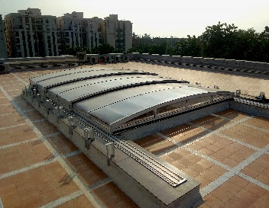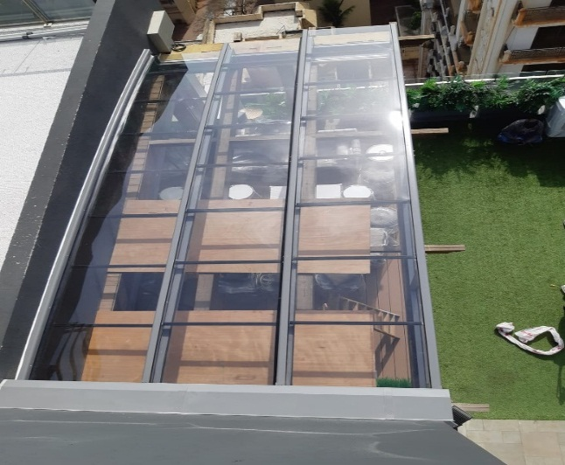

Dear
“NIHVA Technologies Pvt Ltd” are the prominent manufacturer, importer, exporter of a comprehensive assortment in Automation solution and Door Automation establish in 2012. We has in introduced many innovation in Smart Roofing or Retractable Roof.
A Retractable roof is a roof system designed to roll back the roof on tracks so that the interior of the facility is open to the outdoors.
Retractable roof is the new kind of innovation done for Bungalows, Hotels, Hospitals, Villas, Apartments, Commercial, where we can add more glory by allowing partial sunlight to enter in premises at day and sky view at night.

Proposal and Quote
Sales Person:-
Client Name:-
Project Name:-
Project Location:-
Date:-
Quotation No:-
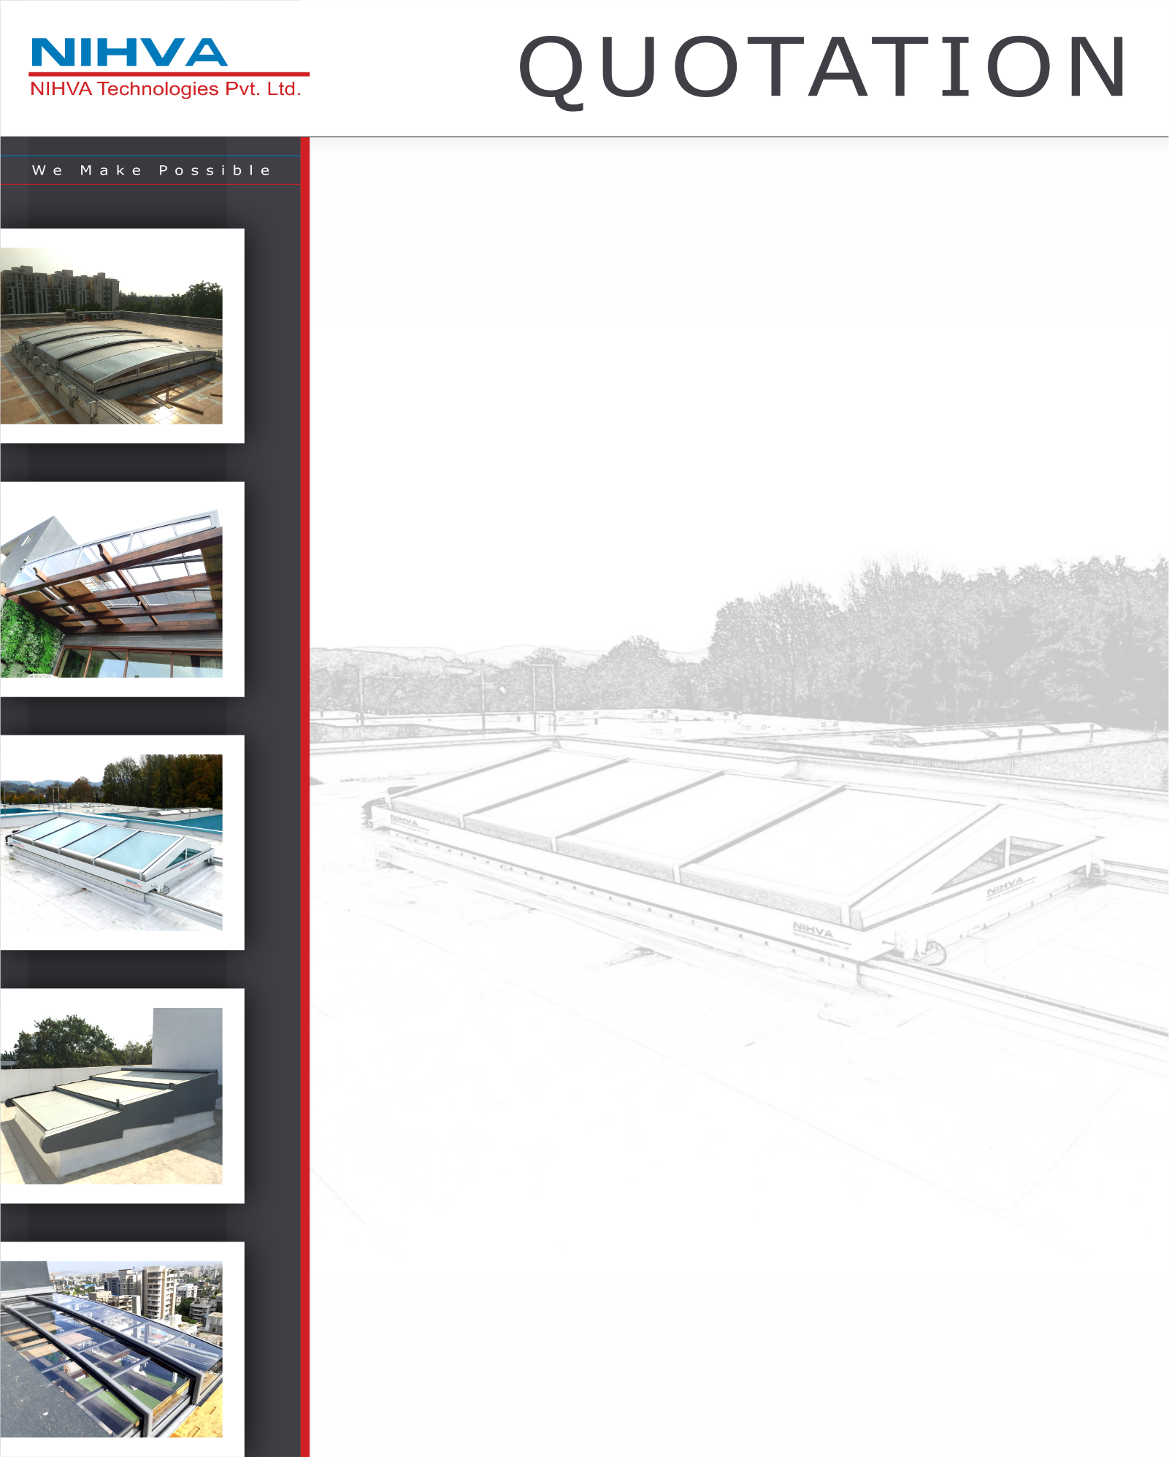

Technical Specification-
- Polycarbonate Israel make Compact/Embossed 4.0 mm thick
- Profile- Powder Coated AL Frame (As per RAL Colour)
- Guide- Anodized AL Guide
- Control Panel
- Motors with Remote Control
- Italian Make BFT Brand
- Single Phase Bi-directional Motor
- Speed- 09-12m/min
- Rack and Pinion Arrangement -Z16/Molude4/Module6
- Mechanical Limit Switch

Supply + Installation Price
P&F Charges
GST 18%
Total with GST
Commercial Specification:-

*Transportation as per actuals and Unloading in Client scope

Warranty
- 10 years for Polycarbonate Sheet.
- 5 years for Powder Coated Aluminium Profile.
- 1 year for motor.
- 1 Year from the date of supply.

General condition-
- Installation will start after receiving of site Readiness Photographs or written Email Communication
- We will mobilize the installation Team in 3-4 Working days, after receipt of site Readiness Confirmation
- For any reason if we need to stop our installation and demobilize Team without Completing the work, then extra cost will be applicable for remobilizing the team.

These items are not included in the offer
- Secured and fully Covered Store area to keep the material
- Scaffolding/Hydra/Carne/Forklift etc. - Required for installation at site
- Electrical Supply on the Single Phase/ three phase point at different places
- Any civil/masonry/ structural work required
- In case of any changes in layout as per site requirements after the shipment of material, the additional quantities and the wastage

Terms and Conditions
- Price - EX Works Pune
- Delivery – 8-9 weeks from date of receipt of Confirmed Purchase order, Advance Payment and Drawing approval.
- Payment – 80% Advance along with Confirmed Purchase order and Balance before dispatch.
- Validity – Validity of offer is 15 days from the date of quotation.

